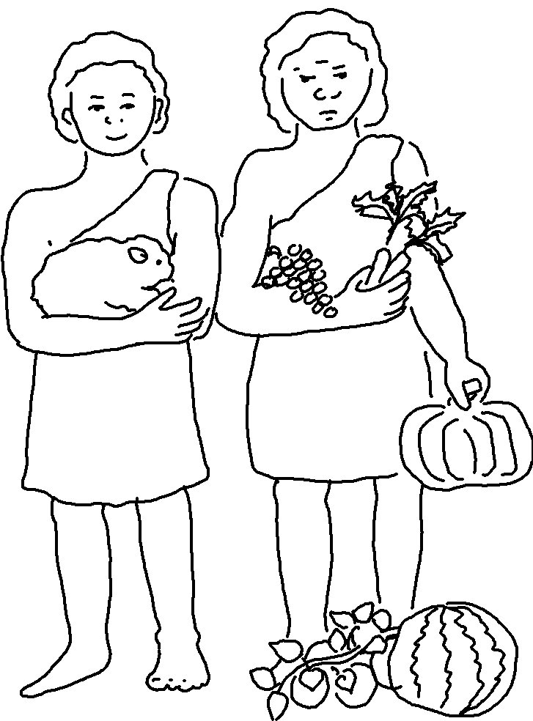
Do what is right and good in the Lord’s sight. Deuteronomy 6:18

